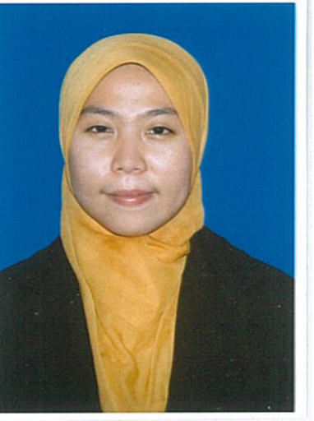 Jl. AMD Raya no.29 Rt.004/01
Pondok Kacang Barat, Kecamatan Pondok Aren
Tangerang Selatan 15226

Phone : 089517749077

Email: dewisandika123@yahoo.co.id

DEWI SANDIKA
PERSONAL DETAILS

Full Name Dewi sandika
Place of Birth Tangerang
Date of Birth May 11, 1989
Gender Female
Religion Islam
Marital Status Single
Nationality Indonesia
Address Jl.AMD Raya No.29 Rt.004/01 Pondok kacang Barat
Kecamatan Pondok Aren, Kab.Tangerang Selatan 15226
Telephone / HP 089517749077
Email Address dewisandika123@yahoo.co.id

HEALTH

Height 163 Cm
Weight 59 kg
Hobby Read Book, Playing Computer
Spent Time Activity Read a book, magazine, travelling, watch TV, playing computer.
Strong Point I am a self motivated, and I am able to work independently and I am as good as working in a team. Also I am eager to learn, meet new challenge and able to work under pressure.

FORMAL EDUCATION

SDN Pondok Kacang Barat 3, Tangerang Selatan 1997 – 2003
MTS Al-Islamiyah Ciledug 2003 – 2005
SMAN 3 Tangerang, Ciledug 2005 – 2007
Universitas Mercu Buana (D3) 2007 – 2010
Universitas Mercu Buana (S1) 2011 – 2013

Cumulative GPA = 3,71 ( scale 4.00 )

SKILL

Language Indonesian, English
Software Accurate,MS Office (Word, Excel, Power Point), Windows XP

WORK EXPERIENCES

Company | Date from – to | Position
Showroom Mobil Toyota | Mei 2010 - Feb 2011 | Admin Billing
PT. Zentrum Graphics Asia | Agst’2011 - Jan 2012 | Finance

PT.Bostik Indonesia Feb 2012 - Now Accounting
MY RECENT PHOTOGRAPH

MY UNIVERSITY TRANSCRIPT
